2253 CFGS Web Application Development

Module 2 – Data Bases

UF2 – SQL Language: DDL and DML
NF4 – Data Manipulation Language
ACTIVITY

ACTIVITY DONE BY  Aaron Andal | 1DAW

Activity 6: Data Manipulation Language

Description

1. Implement next SQL DML statements in HOSPITAL database.

The Entity-Relationship:

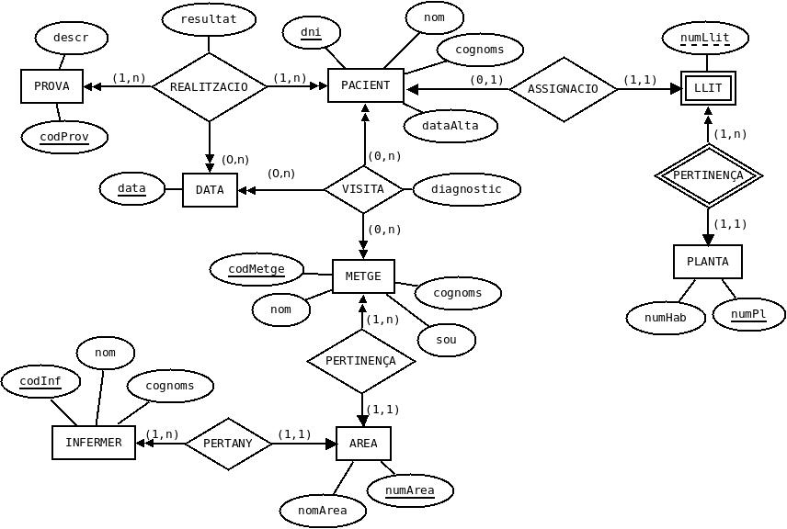
And the relational model:

AREA (numArea, nomArea)

PROVA (codProv, descr)

PLANTA (numPl, numHab)

LLIT (numPl, numLlit)
ON {numPl} REFERENCIA PLANTA

PACIENT (dni, nom, cognoms, dataAlta, numP, numL)
ON {numP,numL} REFERENCIA LLIT (numPl,numLlit)

METGE (codMetge, nom, cognoms, sou, numArea)
ON {numArea} REFERENCIA AREA

INFERMER (codInf, nom, cognoms, numArea)
ON {numArea} REFERENCIA AREA

VISITA (dniPac, codMetge, data, diagnostic)
ON {dniPac} REFERENCIA PACIENT(dni)
i {codMetge} REFERENCIA METGE

REALITZACIO (codProv, dniPac, data, resultat)
ON {codProv} REFERENCIA PROVA
i {dniPac} REFERENCIA PACIENT(dni)

Firstly we have to add a column called pressupost (datatype: decimal) to AREA table to store the money managed by the area.

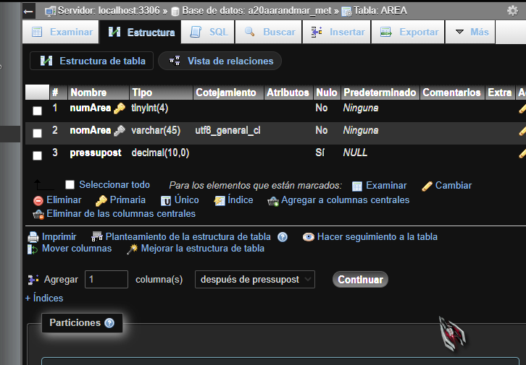

Update all the records inserted to AREA table to give value to pressupost column.

UPDATE AREA SET AREA.pressupost = 100000 WHERE AREA.numArea = 1;
UPDATE AREA SET AREA.pressupost = 120000 WHERE AREA.numArea = 2;
UPDATE AREA SET AREA.pressupost = 65000 WHERE AREA.numArea = 3;
UPDATE AREA SET AREA.pressupost = 500000 WHERE AREA.numArea = 4;

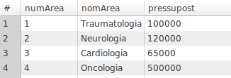
- Show a list of all the doctors.

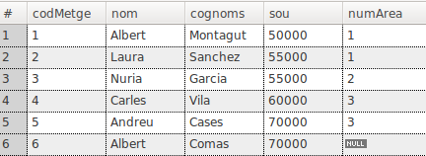
SELECT * FROM METGE;

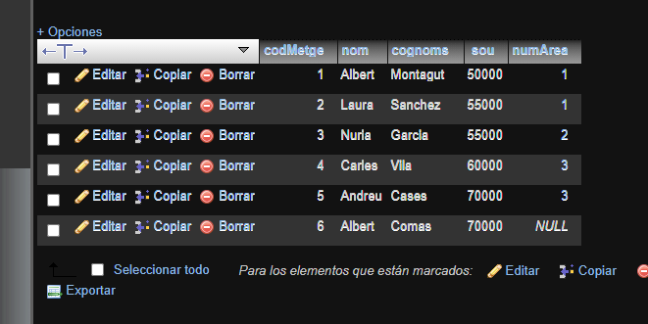

- Show a list of all the doctors assigned to area number 1.

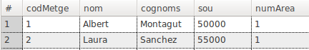
SELECT * FROM METGE WHERE numArea = 1;
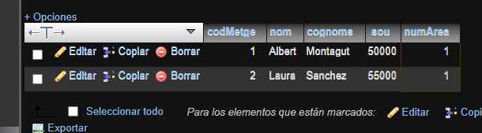

- Show a list of all the patients in floor number 2.

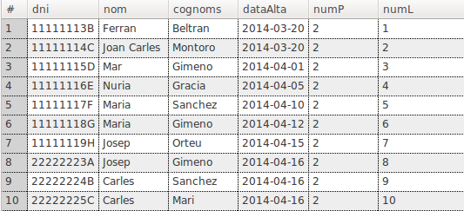
SELECT * FROM PACIENT WHERE numP = 2;

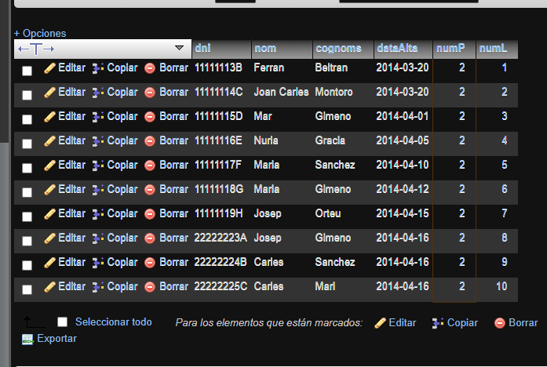

- Show the information of the patient assigned to bed number 1 in floor number 1.

SELECT * FROM PACIENT WHERE numP = 1 AND numL = 1;

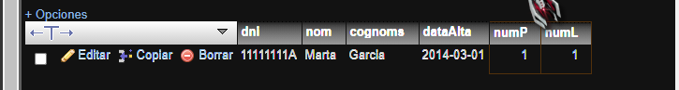

- Show a list of all the doctors (name, surname and monthly salary). The salary stored in the database is annual (you have to divide by 14 and rounded to 0 decimals). Define an alias for the montly salary.
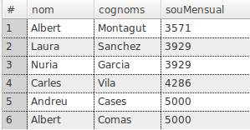

SELECT METGE.nom, METGE.cognoms, ROUND(METGE.sou/14, 2) "SouMetge" FROM METGE;

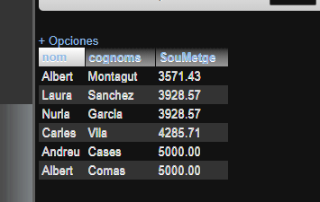

- Show a list ordered by name of all the patients (name, surname and check-in date) assigned to floor number 2.

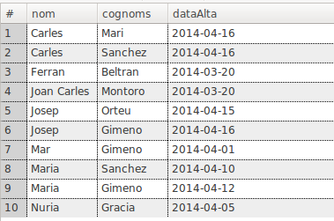
SELECT PACIENT.nom, PACIENT.cognoms, PACIENT.dataAlta FROM PACIENT WHERE PACIENT.numP = 2 ORDER BY PACIENT.nom ASC;
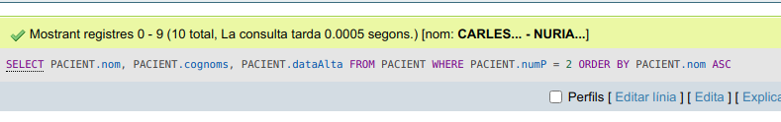

- Show a list of all the patients (all the data) with name beginning by letter 'A'.

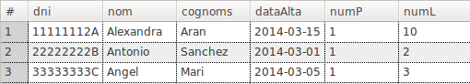
SELECT * FROM PACIENT WHERE PACIENT.nom LIKE 'A%';
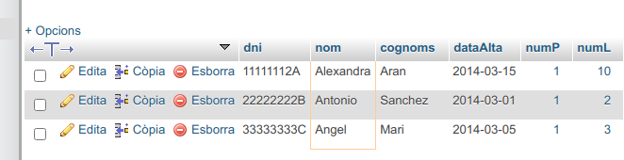

- Show a list of all the patients (all the data) whose name has an 'a' as a second letter.
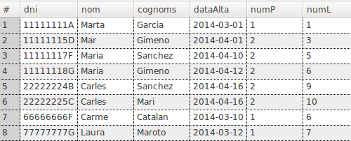
SELECT * FROM PACIENT WHERE PACIENT.nom LIKE '_a%';
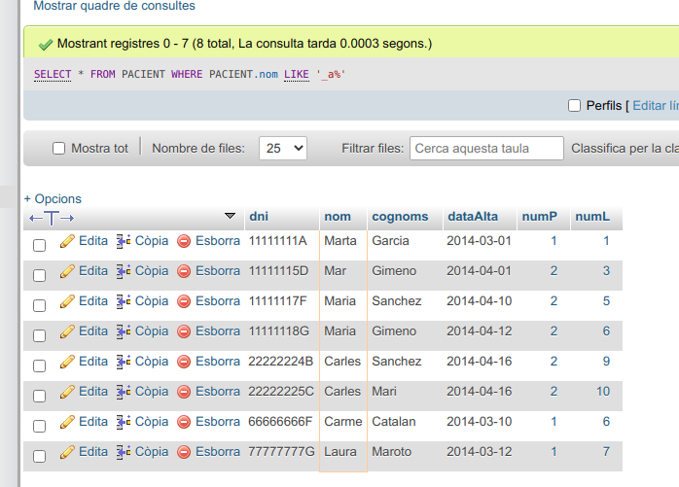

- Show a list of all the visits done between 1/March/2014 and 10/March/2014 (both included). (two statements).

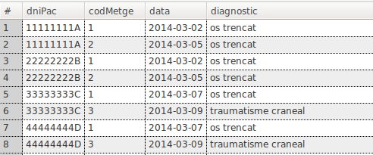
SELECT * FROM VISITA WHERE VISITA.data BETWEEN '2014-03-01' AND '2014-03-10';

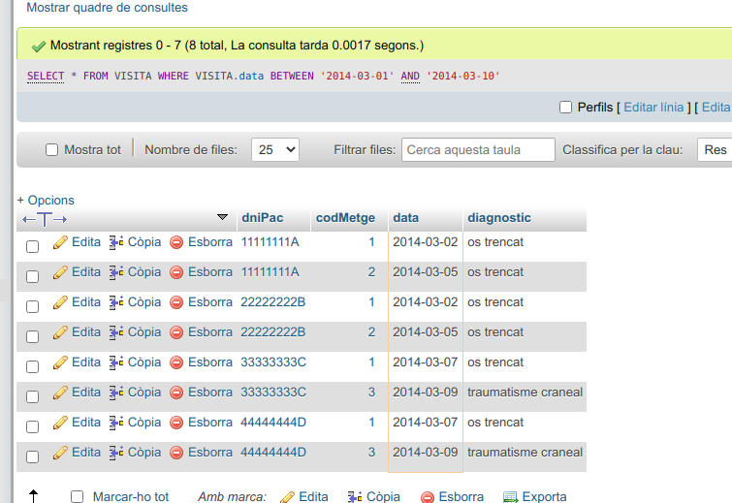

- Show a list of all the doctors who don't have assigned an area.

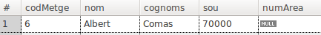
SELECT * FROM METGE WHERE METGE.numArea IS NULL;

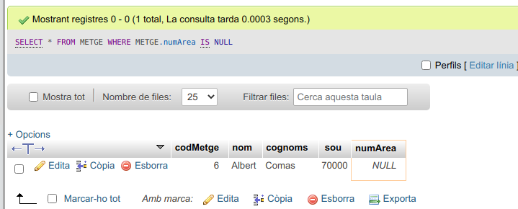

- Show a list of all the doctors assigned to areas 1, 3 or 5. (two statements)

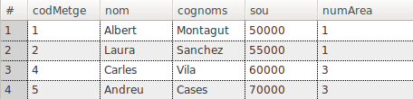
SELECT * FROM METGE WHERE METGE.numArea = 1 OR METGE.numArea = 3 OR METGE.numArea = 5;

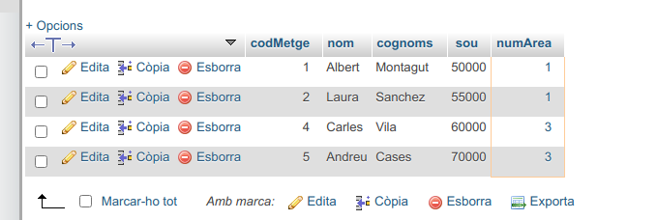

- Show a list of all the doctors (name and surname) with the full name written in capital letters and in the form 'suname, name'.

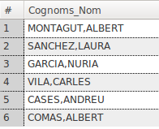
SELECT CONCAT(UPPER(METGE.nom), ',', UPPER(METGE.cognoms)) AS Cognoms_Nom FROM METGE;
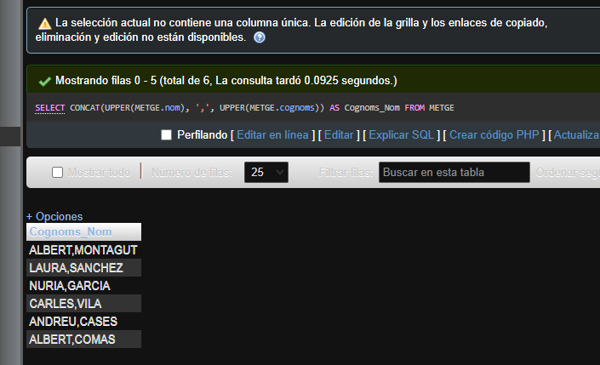

- Show a list of all the visits which have been programmed on Monday.

SELECT * FROM VISITA WHERE VISITA.data = '2014-04-07';

- Show a list of all the visits done between 1/April/2014 and 15/April/2014 (both included). Where data must be showed as in the example (two statements)

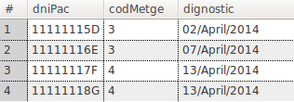
SELECT * FROM VISITA WHERE VISITA.data BETWEEN '2014-04-01' AND '2014-04-15'

- Show a list ordered by surname and name (both by descending order) of all the patients (surname and name) assigned to floor number 2.

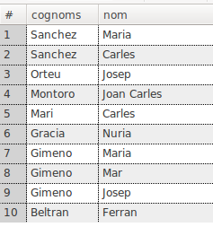
SELECT PACIENT.cognoms, PACIENT.nom FROM PACIENT WHERE PACIENT.numP = 2 ORDER BY PACIENT.cognoms DESC, PACIENT.nom DESC;
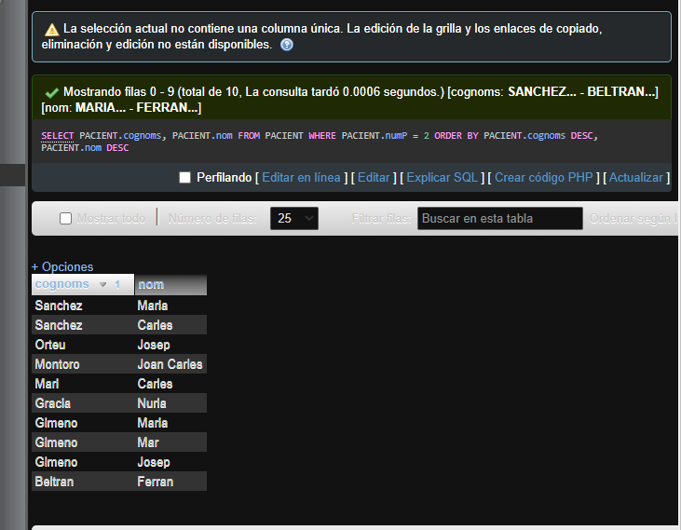

- Show a list of all the areas where there are nurses.

